ST BENEDICT’S COLLEGE


SUBJECT | English | DATE | July 2014
GRADE | 11 | MARKS | 90
EXAMINERS | Mr De Reuck, Mrs De Reuck, Mrs Oosthuysen | MODERATOR | Mrs Nichas
NAME |  | DURATION | 2 ½ Hours
CLASS

COGNITIVE LEVELS
LOW ORDER | 55 | MIDDLE ORDER | % | HIGH ORDER | 45

STUDENT’S RESULT
COMMENT
TEACHER’S SIGNATURE
PARENT’S SIGNATURE

Insructions
- Answer all the questions and number according to the question paper.
- Answer in full sentences.
- Leave a line between each answer.
- Consider mark allocation.
- It is in your best interests to write legibly and neatly.
question 1 – comprehension 26 Marks
Read TEXT 1 and answer the following questions.

  - Who is Boko Haram? 2

1.2 What is the difference between selling and luring children into trafficking? (Introduction) 2
1.4 What would the intention be of the Boko Haram leader releasing a video about the abduction of the Nigerian schoolgirls? 3
1.5 What evidence is there in paragraph 3 to show that Abubakar Shekau of the Boko Haram has no regard for children? 2
1.6 Provide three reasons for the trafficking of children. 3
1.7 What does Susan Bissell’s comment it’s entirely possible, and that is a sad commentary on our times right now (paragraph 4) suggest about the values of society? 2
1.9 Explain the effectiveness of the use of statistics in paragraph 5 to convince the reader of the seriousness of the situation. 2
1.9 In what way would a natural disaster enable child trafficking? 3
1.10 Compare and contrast the portrayal of children in Visuals A and B. Refer to the use of visual techniques in your answer. 4
1.12 Does this article end on an optimistic or pessimistic note? Explain your answer. 3

Question 2 - summary 10 marks

Read TEXT 2, Social media has transformed the way people view news and governments and complete the following:
In no more than 100 words, write a summary in which you discuss how social media has forced the governments of the Middle East to adopt new strategies.

- You must use full sentences.
- Your language use must be accurate and in an appropriate register.
- Include a suitable title.
- Provide an accurate word count at the end of the summary.
- Use your own words.

question 3 – seen and unseen Poetry 21 marks
Read the following Three World War 1 (Dulce Et Decorum Est, Anthem for Doomed Youth and Suicide in the Trenches) poems and answer the questions that follow.

Wilfred Owen
Anthem for Doomed Youth
What passing-bells for these who die as cattle?
Only the monstrous anger of the guns.
Only the stuttering rifles' rapid rattle
Can patter out their hasty orisons.
No mockeries now for them; no prayers nor bells;
Nor any voice of mourning save the choirs,
The shrill, demented choirs of wailing shells;
And bugles calling for them from sad shires.
What candles may be held to speed them all?
Not in the hands of boys, but in their eyes
Shall shine the holy glimmers of good-byes.
The pallor of girls' brows shall be their pall;
Their flowers the tenderness of patient minds,
And each slow dusk a drawing-down of blinds.

Siegfried Sassoon

SUICIDE IN THE TRENCHES
I knew a simple soldier boy
Who grinned at life in empty joy,
Slept soundly through the lonesome dark,
And whistled early with the lark.
In winter trenches, cowed and glum,
With crumps and lice and lack of rum,
He put a bullet through his brain.
No one spoke of him again.
You smug-faced crowds with kindling eye
Who cheer when soldier lads march by,
Sneak home and pray you'll never know
The hell where youth and laughter go.

3.1 Discuss how the following propaganda poster negates the underlying message of Dulce et Decorum Est. Your answer must include close reference to the poem. 4



3.3 Why is the poem Anthem for Doomed Youth an example of anti-war poetry? Discuss with reference to the words used in the poem. 4
3.5 Identify and discuss the effectiveness of two sound devices used by the poet in Anthem for Doomed Youth to portray the horror of war. 4
3.6 Explain the literal and figurative meaning of the rhyming couplet in Anthem for Doomed Youth. 2
3.7 Which ONE of the following three visuals best reflects the intention of the poem Suicide in the Trenches? Provide a reason for your choice. 3

VISUAL A VISUAL B


VISUAL C


3.8 Identify the tone of stanza 3 in Suicide in the Trenches. Quote to support your answer. 2
3.8 How does this tone add to the emotional impact of the poem? 2

QUESTION 4 – VISUAL LITERACY 20 MARKS
The following three advertisements have been taken form the WWF’s campaign entitled STOP WILDLIFE CRIME – IT’S DEAD SERIOUS.
Study the advertisements and answer the questions which follow.


I am not a rug
Every part of the tiger—from whisker to tail—is traded in illegal wildlife markets. Poaching is the most immediate threat to wild tigers. In relentless demand, their parts are used for traditional medicine, folk remedies, and increasingly as a status symbol among wealthy Asians.

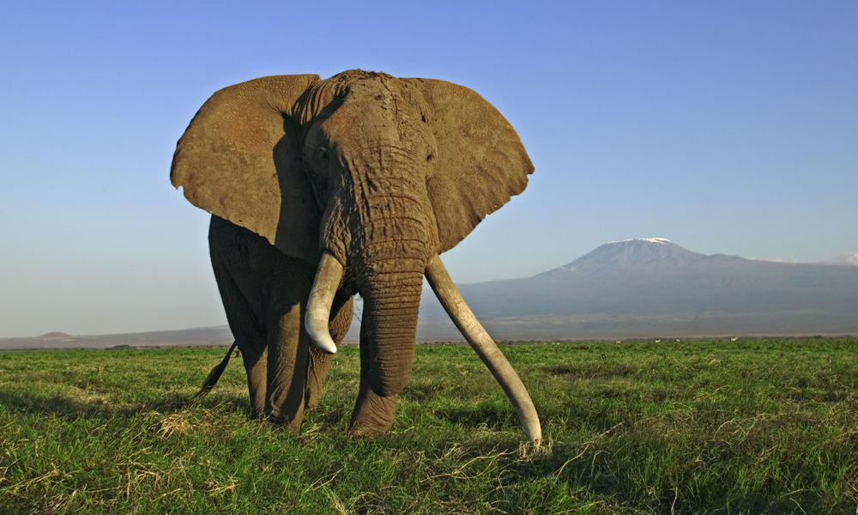

I am not a trinket
Tens of thousands of elephants are killed every year for their ivory tusks. In 1989, the Convention on International Trade in Endangered Species of Wild Fauna and Flora (CITES) banned the international trade in ivory. However, there are still some thriving but unregulated domestic ivory markets in a number of countries, which fuel an illegal international trade.

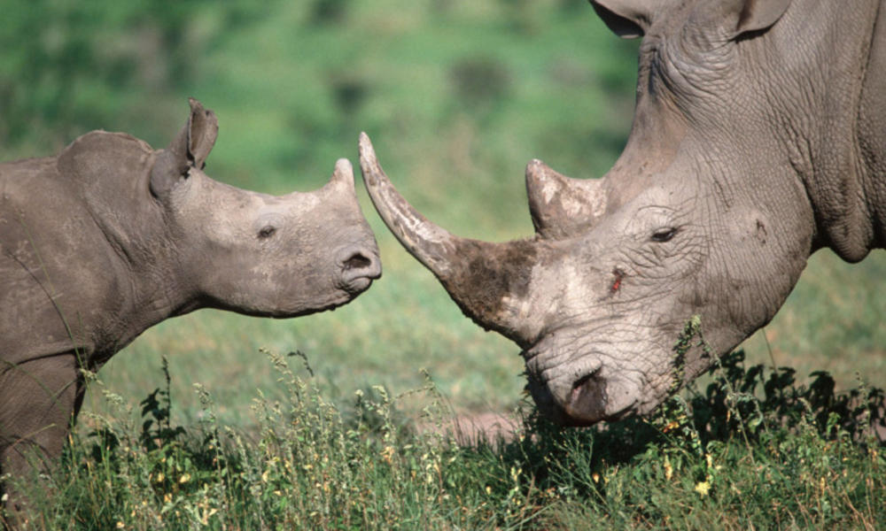

I am not medicine
At least two rhinos are killed every day due to the mistaken belief that rhino horn can cure diseases. The main market is now in Vietnam where there is a newly emerged belief that rhino horn cures cancer. Rhino horn is also used in other traditional Asian medicine to treat a variety of ailments including fever and various blood disorders. It is also used by wealthy Asians as a cure for hangovers.
4.1 Discuss the effectiveness of the pun in the campaign’s slogan Stop Wildlife Crime – It’s Dead Serious. 3
4.2 The advertisers have chosen to use images of majestic animals as opposed to gruesome images of butchered animals. Do you believe that this approach is more effective? Explain fully. 3
4.3 How is the impact of each advertisement enhanced by the use of the personal pronoun ‘I’? 2
4.4 Identify and discuss the effectiveness of the metaphor in However, there are still some thriving but unregulated domestic ivory markets in a number of countries, which fuel an international trade. 3
4.5 The body copy of each advertisement is factual and not emotive. How does this affect the impact of each advertisement? 2

Study the following three cartoons and answer the questions which follow.
CARTOON 1 CARTOON 2
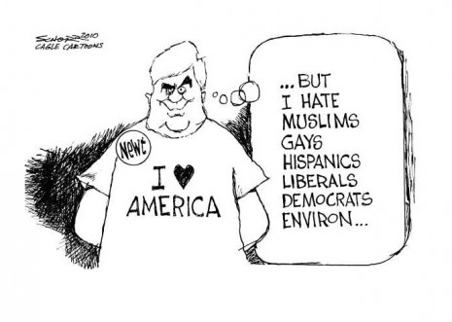
CARTOON 3

4.6 Explain the irony in cartoon 1. 2
4.7 How is the irony in cartoon 1 enhanced by what is said in cartoon 2? 2
4.8 What is the result of this irony as revealed to us in the body language of cartoon 3? 3

question 5 textual editing 13 marks
Refer to TEXT 3 and answer the following questions.
5.1 From the context of the text, what do you think a ‘meta-persona’ is? (2)
5.2 What is the difference between ‘adolescent doodlings’ and ‘undiscovered gems’ of writing? (2)
5.3 Explain the effectiveness of the use of onomatopoeia in ‘abuzz’. (2)
5.4 The text makes use of informal language. Quote an example of this usage and suggest a reason for this. (3)
5.5 Explain the use of inverted commas around the word ‘dork’ (paragraph 3). (1)
5.6 "The fashion industry is really aware at the moment that it has to look at new territories," said Grand. (paragraph 6)
Rewrite this sentence in Reported Speech. (2)
5.7 Why would the write capitalize the ‘New Next Big Thing’ (paragraph 4) (1)

TEXT 1
The following article, written by Eve Conant, originally appeared in the National Geographic on May 15, 2014.

Nigeria's Schoolgirl Kidnappings Cast Light on Child Trafficking

Boko Haram's threat to sell the kidnapped girls "in the market" highlights the plight of children sold or lured into exploitation.
1. The nearly 300 Nigerian schoolgirls kidnapped last month from their boarding school in Chibok by the Islamist militant group Boko Haram are suspected to be deep in Nigeria's northeastern Sambisa Forest, officially a game reserve but long a redoubt for smugglers and criminals hiding in its dense and thorny scrub.
2. With the region's remote landscape and unprotected borders, many fear that at least some of the girls may have been dispersed to neighbouring Chad and Cameroon, either to other militants or into the global marketplace of children destined for every manner of work, from domestic or agricultural labour to sexual exploitation, forced begging, and child soldiering.
3. "I abducted your girls," said the smiling Boko Haram leader, Abubakar Shekau, in a video that was circulating shortly after the raid. "I will sell them in the market, by Allah. There is a market for selling humans."
4. There is no evidence yet that Shekau has followed through on his pledge, but "it's entirely possible, and that is a sad commentary on our times right now," says Susan Bissell, chief of child protection for the United Nations Children's Fund (UNICEF). "Anything can be bought and sold in our world, even a child."
5. The International Labour Organization estimates that about 1.2 million children are trafficked worldwide, and the U.S. State Department says as many as 27 million men, women, and children are victims of trafficking at any given time. In many countries "borders are porous and law enforcement is weak," says Bissell; in addition, some one billion children are currently living in countries affected by conflict, another driver in the trafficking phenomenon.
Nigeria's Trafficked Children
6. Countries can be a source, transit, or destination country for trafficking. There are also countries—like Nigeria with its vast natural resources, wealthy classes, and travel infrastructure—that can be all three at once, says Benjamin N. Lawrance, an expert on trafficking in Africa who holds the Conable Chair in International Studies at the Rochester Institute of Technology in New York.
7. "Nigeria is an important location for trafficked children coming from many countries, primarily for domestic work, for mining, for laboring in cacao fields or other agricultural industry, and also for prostitution," he says, adding that prostitution is a much smaller part of the child-labour economy. Neighboring Cameroon and Chad, he says, are also source, transit, and destination countries.
8. The girls taken by Boko Haram, Lawrance says, could represent an "intersection of trafficking, forced marriage, and child soldiering." Much like the kidnapping of children by the Lord's Resistance Army in Uganda and other African countries, the kidnapped schoolgirls could technically fall under the definition of child soldiers if they are living with soldiers and pressed into cooking, cleaning, or portering for them or are forced to comply with the sexual demands of the militants.
9. As for the kidnapped girls, Rachel Yousey, the State Department's senior coordinator for trafficking in persons, says, "All we can say at this time is that they are definitely victims of kidnapping." But she adds: "What we do know about Boko Haram, in general, is that Boko Haram does forcibly recruit or abduct children for various purposes—for intelligence gathering, for spying, for transporting, portering, for burning down structures like schools and churches, for providing information before subsequent attacks. In those types of roles you would definitely classify children [who] are doing those things as child soldiers as well as trafficking victims."
VISUAL A
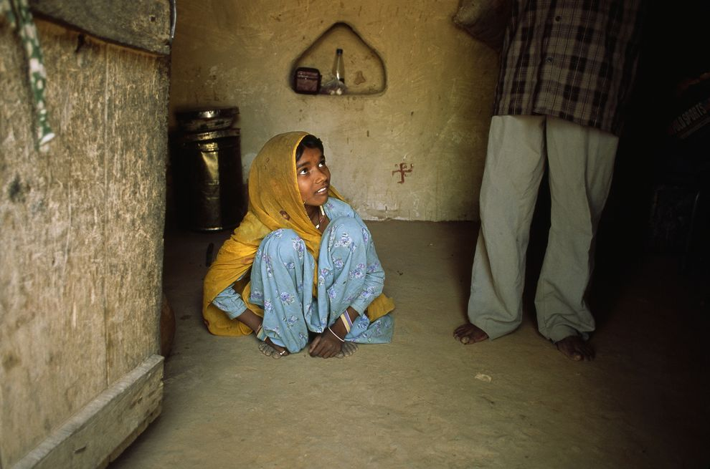
A child bride cowers at her husband's feet in Rajasthan, India.

VISUAL B
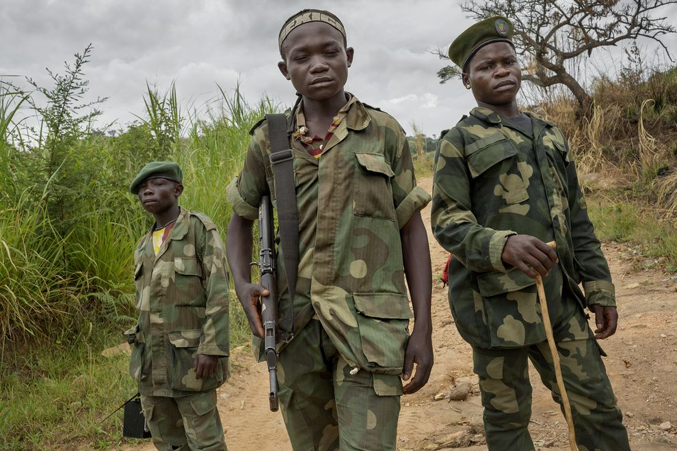
Child soldiers, recruited by a warlord named Cobra Matata, patrol the Bavi gold mine outside of Gety, Orientale Province, Democratic Republic of the Congo.
Vulnerable Populations
10. Poverty, war, and poor law enforcement aren't the only factors leading to the exploitation of children. "Geography can play a significant role in trafficking," says Yousey. Natural resources such as mines that require labour and are far from the watchful eyes of authorities, remote areas where traffickers can operate or hide, and porous borders can all contribute to the problem.
11. So can natural disasters, especially when the international relief teams have already left, says Yousey, but families' lives remain upended. Once the safety net is gone, she says, "that makes people more vulnerable to promises made to themselves or their children" to migrate for work and potentially fall into exploitative situations.
12. "We have concerns that natural disasters in the medium and longer term can make people very vulnerable to trafficking," and for that reason, for example, "we are looking at the Philippines typhoon situation very closely," says Yousey.
13. Whether as a result of war, poverty, abduction, or "the widespread increase of natural disasters," says Bissell, too many children are separated from their families and fall into the wrong hands. "We have lots of techniques for tracing them, but many of them fall between the cracks."

TEXT 2

Social media has transformed the way people view news and governments
Nadeem Hanif
June 23, 2014Updated: June 23, 2014 21:54:00
__________________________________________________________________________________
DUBAI // Rapid growth of technology and social media has changed the way people in the Middle East receive news and view governments.
The inaugural Social Media Summit at the Armani Hotel in Burj Khalifa on Monday heard governments and the media had to adapt to the way younger generations are using technology.
“Governments must now engage with their citizens in a proactive way,” said Samir Al Rifai, the former prime minister of Jordan who is now a senator and chairman of the foreign affairs committee.
“For the younger generations who have grown up with social media it is no longer good enough for governments to react to news, they must be more active in getting their message across.”
People are far more likely to believe information they receive through social media sharing than traditional means, Mr Al Rifai said.
Social media also provided an opportunity for governments to get their views across directly to citizens without the filter of a news editor.
“Technology now means young people in the Middle East identify themselves more with young people from around the world than they do with their forefathers,” he said.
He said 30 per cent of people in the Middle East considered social media their main source of news.
“The younger generation expect their governments to be transparent and be responsive to their needs,” Mr Al Rifai said.
“They are the generation that has grown up with the Xbox and YouTube, so state television isn’t good enough for them now.”
He said younger people wanted their governments to be honest, efficient and accountable.
Mohammed Burhan, chief executive of CNBC Arabia, said the role of the media had shifted from news gathering to news verification.
“Anyone with a smartphone can now report and take pictures of something and put it on Twitter. That means our role as the media must be first of all to verify it.”
Media groups can no longer set the agenda and were often reacting to news breaking on social media.
Osman Sultan, chief executive of du, said social media and technology would provide the platform to allow people in the Middle East to reach their potential.
“We have been given a three-year deadline to transform Dubai into the world’s first smart city,” Mr Sultan said.
As part of those plans, thousands of sensors will be installed in lifts, apartments and lampposts, he said.
“This will allow for a foundation whereby people can come up with apps or services that can help people.”
About 54 per cent of the UAE population have a Facebook account with 900,000 people signing up last year, Ms Al Marri said.
nhanif@thenational.ae
TEXT 3
The teen bloggers who took over the internet
John Crace, The Guardian, September 2009
It's a teenage rite of passage to invent new worlds: worlds of the imagination, gangs, cliques and clubs, worlds apart from adults. And then came the internet, where anyone can be anything, a meta-persona of your own choosing. There are hundreds of millions of blogs; a new one is created each second – many by teenagers.
Most are probably adolescent doodlings, some may be undiscovered gems. And then there are the blogs which – usually with a fair bit of luck - suddenly set the blogosphere abuzz. Usually, these are sites that look and read more like the next generation of "e-zine" than something knocked up in a 15-year-old's bedroom.
Such blogs from all over the world (although most commonly the US) attract tens, sometimes hundreds, of thousands of readers a month. They can pull in advertising revenues (albeit small), and their creators become stars when they come to the attention of the mainstream media. Tavi Williams, a 13-year-old self-confessed "dork", became an influential player in the fashion world almost overnight after her Style Rookie blog was featured in the New York Times last year.
You can understand the NYT's interest. Adults have always been desperate to get an insight into what teens are thinking, and business even more so. Somewhere out there is the New Next Big Thing, and it's almost certainly being dreamed up by a bunch of teenagers. Even Katie Grand, stylist, editor and one of the most influential women in fashion, has devoted the second issue of her magazine, Love, to teens, with bloggers to the fore.
"The fashion industry is really aware at the moment that it has to look at new territories," said Grand. "When I was having meetings with advertisers for this issue, two big Italian houses said they felt that their clients were getting older and they weren't looking at the youth market enough.
"The difficult part was motivating anyone from that teen age group to get involved with a magazine. Very few kids are bothered about the printed word; we would work really hard on finding these kids, but then you'd get a call at six in the morning saying, 'I've missed my train, so I'm not coming to the photo shoot.'"

